March 2021

Dear Parent / Carer,

In order for all students to engage fully with the mathematics curriculum it is essential that each student has their own calculator. We are therefore seeking your co-operation to ensure that your child has a calculator. It is important that each student becomes familiar with how their calculator works so that in exam situations they are able to use it efficiently.

The school is able to purchase a CASIO FX83GTX Scientific Calculator on your behalf at a cost of £8:50. This is considerably cheaper than they can be purchased in the shops. It will serve your child well throughout their school career. If you would like to take advantage of this offer then the calculators will be available to purchase from the Maths Faculty when your child starts in September and you will be able to pay online. A reminder will be issued to all students in September.

If, however, you would prefer to make your own arrangements then we strongly recommend the Casio FX 83GTX

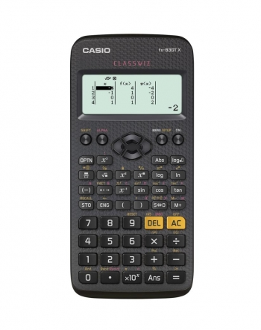

Yours sincerely,

James Barrett
Maths Faculty

