Application & Medical Forms

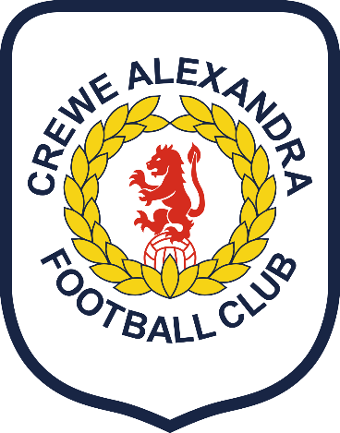
PARENT / Guardian CONSENT FOR An event

PLEASE COMPLETE IN BIRO AND USE BLOCK CAPITALS

Sandbach Police - Cheshire Constabulary
Participant Full Name:
Date of Birth:
Male/Female:

Emergency contact details:
Name:
Relationship to participant:
Telephone (Home):
Mobile:
Email:
Address:

Medical
- Any conditions requiring medical treatment, including medication? YES/NO*
If YES, please give brief details below,
- Please indicate what type of pain/flu relief medication your child may be given if necessary:
Paracetamol Ibruprofen Please indicate by ticking relevant box(es)
Medical Details:

Family Doctor Name:
Telephone:
Address:

Declaration
By signing below, I agree to my child, as named above, taking part in this event.
I agree to my son/daughter/ward’s* participation in the activities described and I acknowledge the need for my son/daughter/ward* to behave responsibly throughout the event.
I agree to my son/daughter/ward* receiving medication as instructed and any emergency dental, medical or surgical treatment, including anaesthetic or blood transfusion, as considered necessary by the medical authorities present. I understand the extent and limitations of the insurance cover provided as detailed by trip leader.
I agree to my son/daughter/ward making their own way to and home from the event YES/NO As part of the activities your son/daughter/ward* are involved in Cheshire Police/Crewe Alexandra/Premier League Kicks may take photographs or video footage to use in printed publications or publicity or promotional material including the local press. Can we use the young person’s photograph in this way? YES/NO*

Signed:
Completed by: | Full Name, Block Capitals
Date:

* Please delete as application

ONCE COMPLETE, PLEASE RETURN TO: SALT.WARS@CHESHIRE.POLICE.UK

